Functional and Non-Functional Requirements (FR & NFR):
Below are all the Functional and Non-Functional Requirements that I have identified:
Functional Requirements (FR):
1. User Accounts
1.1 The system allows users to register.
1.2 The system allows users to log in.
1.3 The system allows users to log out.
1.4 The system allows users to update account details.
1.5 Usernames must be unique.
2. Room Booking
2.1 The system displays all 12 function rooms.
2.2 The system shows room availability.
2.3 The system allows one booking per room per day.
2.4 The system enforces a maximum capacity of 200 guests.
2.5 The system prevents bookings past 12am and before 6am.
2.6 The system applies additional charges automatically.
2.7 User can update a booking.
2.8 Users can cancel a booking.
3. Services
3.1 The system allows users to select services.
3.2 The system calculates total cost automatically.
3.3 The system displays a full cost breakdown.
4. Staff Allocation
4.1 The system assigns staff based on selected services.
4.2 The system prevents staff from being double-booked.
4.3 The system automatically assigns an event manager.
5. Admin System
5.1 Admin users manage rooms.
5.2 Admin users manage services.
5.3 Admin users manage staff.
5.4 Admin users view all bookings.
6. Database Management
6.1 The system stores user account data in a secure database.
6.2 The system stores booking details, including room, date, time and services.
6.3 The system links tables using relational data.

Non-Functional Requirements (NFR):
1. Security
1.1 Passwords are encrypted.
1.2 Role-based access is enforced.
1.3 Unauthorised access is prevented.
1.4 Users can only access their own bookings.
2. Performance
2.1 Pages load within 3 seconds.
4. Usability
4.1 The system is easy to use.
4.2 The booking process is simple.
4.3 Forms provide clear validation and error messages.
5. Maintainability & Scalability
5.1 Prices and services are easy to update.
5.2 New rooms and staff are supported.
5.3 The system allows future expansion.

6. Data Integrity
6.1 The system prevents double-booking of rooms and staff.
6.2 The database uses primary and foreign keys to maintain relationships.
6.3 Unique booking IDs are generated automatically.

7. Scalability & Maintainability
7.1 The system allows future expansion (e.g., online payments).
7.2 Code follows consistent structure and naming conventions.
7.3 Key system actions are logged for monitoring and auditing.

User Acceptance Criteria (UAC):
Here are the UAC’s that I have identified:
1. User Accounts
1.1 Given a user enters valid registration details, when they submit the form, then an account is created.
1.2 Given a user enters valid login details, when they log in, then they are taken to their account details.
1.3 Given a user updates account information, when they save changes, then the updates are stored with confirmation.
2. Room Booking
2.1 If a room is available on a selected date, when a user attempts to book it, then the booking is allowed with confirmation.
2.2 If a room is already booked, when another user attempts to book it, then the booking is blocked.
2.3 If a user selects over 200 guests, when they attempt to confirm, then the booking is rejected.
2.4 If a booking exceeds permitted times, when confirmation is attempted, then the system blocks the booking.
3. Pricing
3.1 Given a booking ends after 10pm, when the total cost is calculated, then an additional charge is applied.
3.2 Given a booking starts before 9am, when the total cost is calculated, then an additional charge is applied.
3.3 Given services are selected, when reviewing the booking, then the full cost breakdown is shown.
4.UI
4.1 UI is easy to navigate
4.2 Contrasting colours on the website
4.3 Text is easy to read and understand

Colour Scheme:
Here is the colour scheme from my website:

- #D5C6E0


- #AAA1C8


- #F5E6E8


- #967AA1


- #192A51

I have chosen this as my colour scheme due to the fact that there are 2 main colours that contrast so that I can use either of these for my main page colour and have text on the page that is easily visible and the colours are contrasting. I have also chosen this colour scheme as there are colours that stand out which will catch users eyes. I have not chosen a black and white scheme as this is bland and boring and this colour scheme provides a softness that is visually appealing to users.

Website UI:
I have chosen this colour scheme as there is contrasting colours (UAC 4.2) and I have also avoided using any green or red shades. This is so that users that are colour blind or have sight issues are able to differentiate between each colour and that text will be easier to see due to the contrast.
This is my home page that users will first see when they load up into the website. This page features a nav bar that clearly states what page you will go to when you click on a different section. This makes its easy for the user to navigate through the page (UAC 4.1). I have also used brighter colours for the text and different coloured text for the headings and body text so that the heading text catches the users eyes and the body text is a slightly darker colour than then title but is still contrasting to the background of the website so the text can be read and understood easily (UAC 4.3).
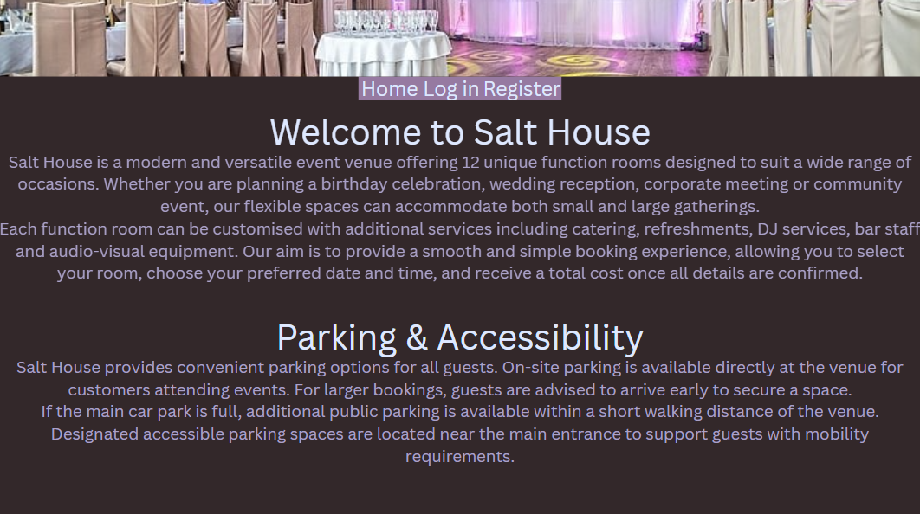
This is my register page. This page allows the user to register an account (FR 1.1) so that they can log in to (FR 1.2) gain access to create a booking. I have clearly stated to the user where to register to remove any confusion and make it easy for them to navigate (UAC 4.1) to the registration form. I have also used a submit button so the user know where to confirm their details. Users will also be restricted and must create a unique username (FR 1.6) When the user has registered they will be sent back to the homepage with the appropriate user message as to if the account was successfully/unsuccessfully created.
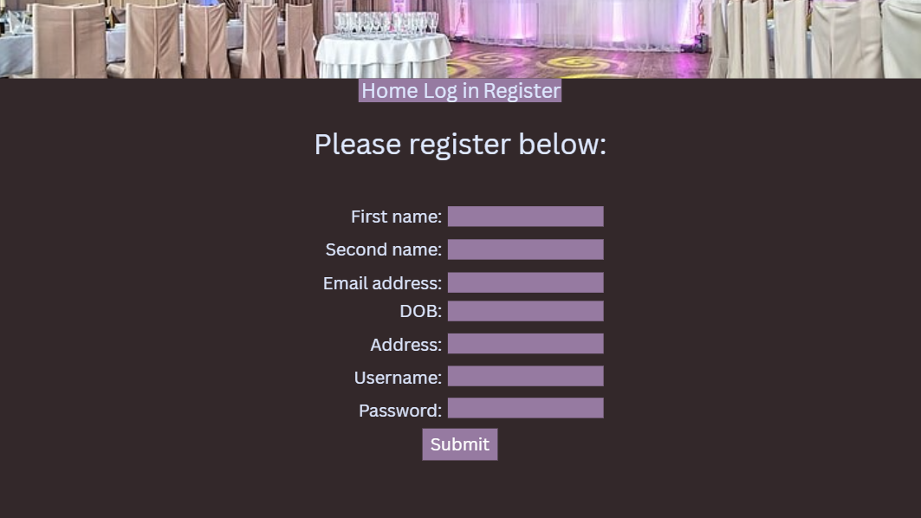

This is my user account details page. After registration the user is redirected to the account details page. In this page the user can change their account details (FR 1.4) but only if they enter their current password. User will not be able to see their password for security reasons but can see all their other details.
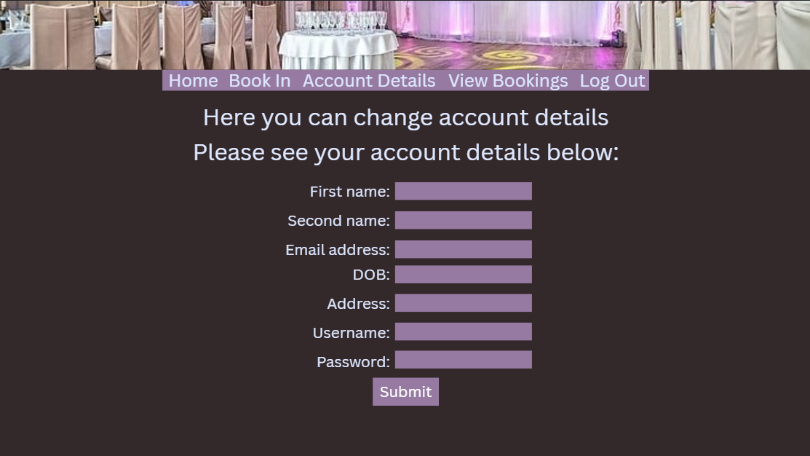

Here is my book in page. When the user goes to book in there will be a drop down list where the user can see all the available function rooms on the date and time that they have selected (FR 2.1, 2.2). After selecting a room all the extra services with costs will be shown and the user can select the services they want to add on (FR 3.1). The user can only back a booking between 6am and 12pm with a limit of 200 guests (FR 2.4,2.5). Only one room and be booked once a day (FR 2.3). After selecting everything the user will be shown the total cost and if they have a late/early service fee (FR 3.2, 3.3, 2.6).
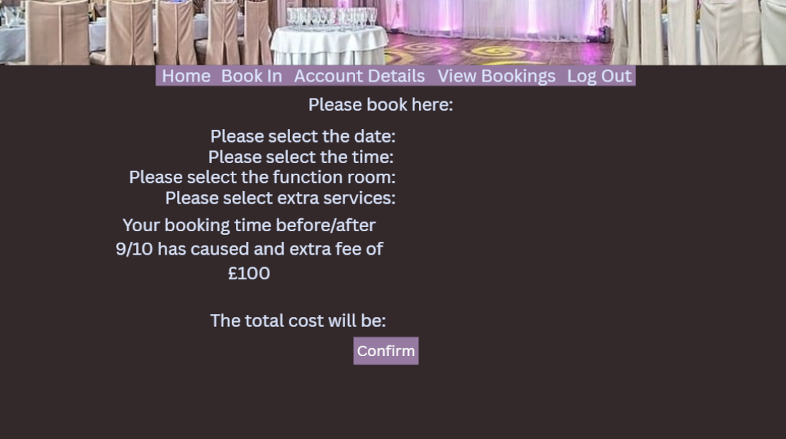
I cannot visually show the log out page due to the fact that there is not any display on the page it will just be a few lines of code that will terminate the session and redirect the user back to the homepage with a logout message.
I also cannot visually show the cancel booking page as there is no display display it is a few lines of code that calls a subroutine that cancels the booking and redirects them back to the view booking page.

Here is my view booking page. When the user loads this page if they do not have any bookings it will state that the don’t have any bookings but if the user does have any bookings it will display the bookings and give 2 options after the booking that will be amend or cancel booking (FR 2.7, 2.8).
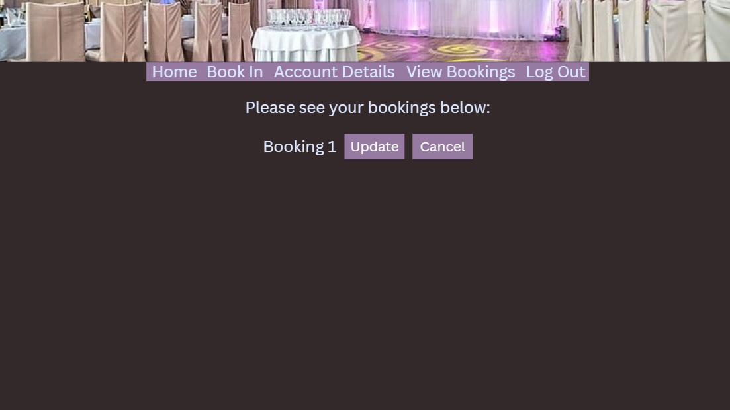
Here is my update booking page. This is where users can update their booking details like changing the time, date, room and services. This page works exactly like the book in page but instead of creating a new booking it just updates the booking that the user chose.
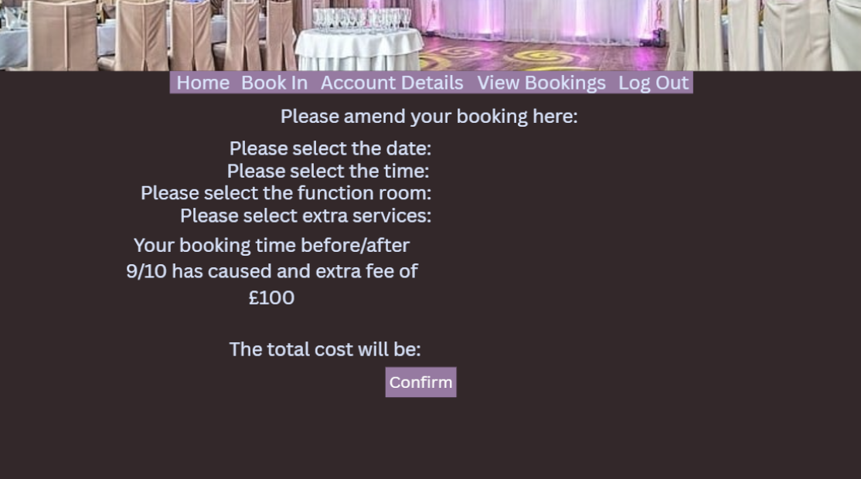

This is my login page it will allow then user to log in given the have already have an account(FR 1.2). I have clearly stated where the user should enter their password and username and I have also made the submit button a different colour that contrasts to the website so users can clearly see where they need to press to submit their details (UAC 4.2,4.3)
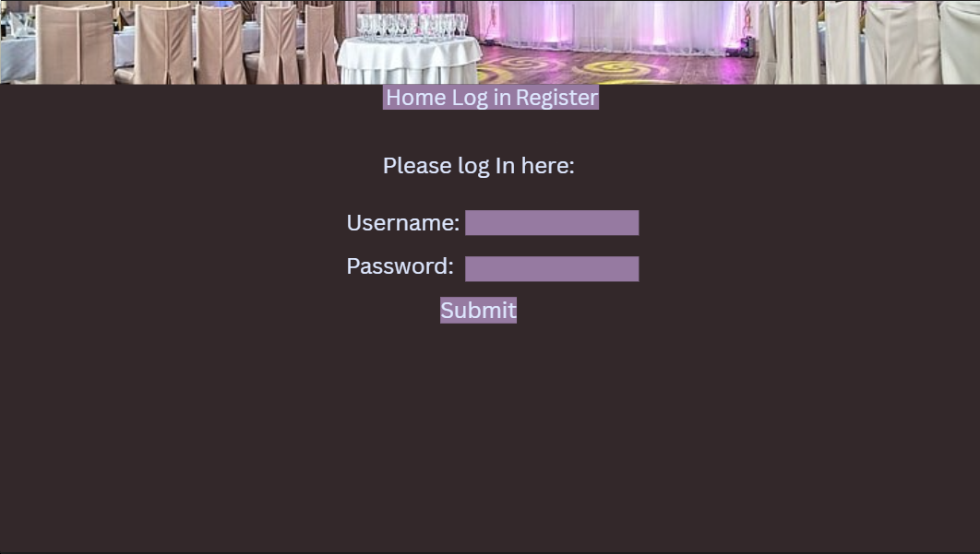

Decomposition:
The diagram below is a generalised over view of the structure of my website and how the order of pages a user would typically access. First they would either create an account if the do not have one and then after creation they will be redirected to the login page with a message if it was successful or not. Then the user will log in and will be redirected to the user details page if successful or stay on the login page if unsuccessful full and will be given a messaged based on if it was successful or not. Then the user will go to the booking page to create a booking, if the booking is successful they will be redirected to view booking page with a message where they can see the booking that has just been created and if they booking is unsuccessful the user will stay on the page and be given a message. Then after creating a booking the user will go to the logout page and logout of their account or if the user wants to amend/cancel their booking they will click the buttons next to the booking they want to change/cancel and if they are changing the booking they will be taken to a page that is similar to the book in page but here they can change their booking and if they want to cancel they will click the cancel button on the page and it will cancel the booking and redirect them to the view booking page. Then the user will log out after.

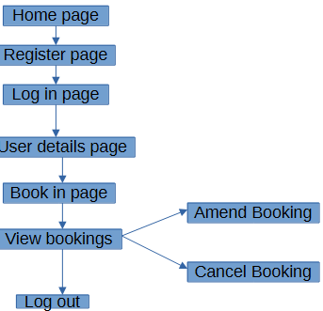

Entity Relationship Diagram (ER diagram):
Here is my ER diagram that shows how the different tables in my database and how they link up with primary and foreign keys and what the fields are and what they do.
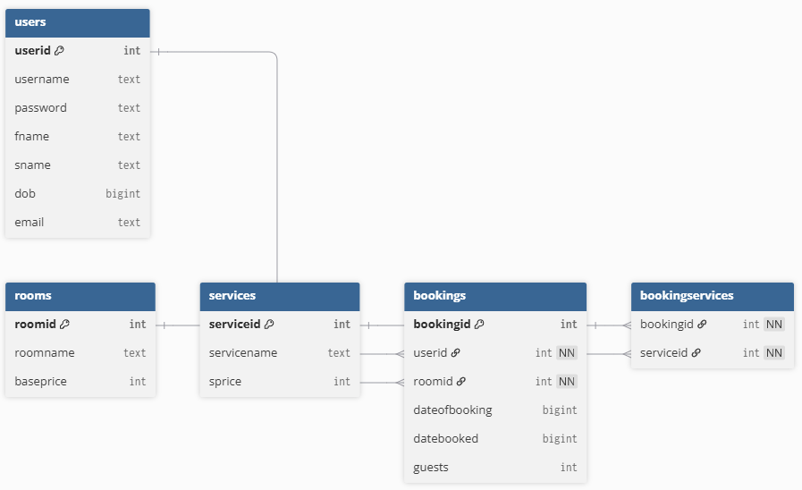
Users Table:
I have named this table Users because this is where I will store my users details upon registration.
userid | fname | sname | dob | email | username | password
This is the primary key of the table. Upon a new user registering this will automatically increment and give each user a unique id which will be an INT This is why I have called is userid. | This is where the first name of the user will be stored as text. This is called fname due to the first name being stored in this field. | This is where the surname of the user will be stored as text. This is called sname due to the surname being stored in this field. | This field is called dob because this is where the users date of birth will be stored. This will be stored as an INT because I will be using Unix Epoch time to store dates | This field is called email because I will be storing the email as text in the field | This field is called username because I will be storing each users unique username in this field as text. | This field is called password because I will be storing the users hashed password in this field as text (NFR 1.1).
Bookings Table:
I have called this table bookings due to the fact that I will be storing all users bookings in this table.
bookingid | userid | roomid | dateofbooking | datebooked | guests
This is a primary key that upon a booking being created it will automatically get assigned a unique number so that’s why I have called it booking id. Stored as INT | This is a foreign key that is establishing a link between the user table and the bookings table so that the booking can be tied to the user (FR6.3). The field name doesn’t need to be the same at the primary key as this is just a reference to establish the link. | This is also another foreign key that is establishing a link between the booking table and the rooms table so that the booking can be tied to the room. The field name doesn’t need to be the same at the primary key as this is just a reference to establish the link. | This is the field that will store when the booking was made as an integer due to me storing dates in Unix Epoch time. I have called this dateofbooking due to the fact that the date of when the booking was made will be stored in here. | This is the field that will store when the booking will take place as an integer due to me using Unix Epoch time. I have called this datebooked because this stores the date that the booking will take place. | This is the field that will store the amount of guests as an INT. I have called this field guests because it stores the amount of guests that will be attending.

Rooms Table:
roomid | roomname | baseprice
This is the primary key for the rooms. When a room is created it will get a unique key so hence the same room id. This is stored as an INT. | This is where the room name is stored as a text hence the field is called roomname. | This is where the rooms base price is stored as a decimal so hence the name baseprice.

Services:
serviceid | servicename | sprice
This is the primary key that each service will be assigned upon creation that is unique to that service hence the field name serviceid. This is stored as an INT. | This is where the service name will be stored as text hence the field name servicename | This is where each service price will be stored as a decimal hence the name sprice.

BookingServices:
The relationship between bookings and services is many-to-many, as a single booking can include multiple services and each service can be linked to multiple bookings. To fix this, a link table is used, containing foreign keys from both the Bookings and Services tables. This converts the many-to-many relationship into two one-to-many relationships, ensuring data integrity and preventing duplication. These two keys create a composite key together.
bookingid | serviceid
This is a foreign key from the booking table that is being used to link a booking to the services tied to it. Stored as an INT and the field name doesn’t need to be the same at the primary key as this is just a reference to establish the link. | This is a Foreign from the services table that is being used to link the services to a booking. Stored as an INT and the field name doesn’t need to be the same at the primary key as this is just a reference to establish the link.

Table Structure:
Users:
Field name | Data Type | Key Type | Example data | Justification
userid | INT | Primary | 1 | This is used to uniquely identify users and be able to create links with other tables.
fname | TEXT | N/A | john | This is where the users first name is stored.
sname | TEXT | N/A | smith | This is where the users last name is stored.
dob | INT | N/A | 117700783 | This is where the date of birth is stored in Unix Epoch time so that I can use a calculation to get the users age.
email | TEXT | N/A | email@mail.com | This is where the users email will be stored.
username | TEXT | N/A | bob123 | This is where the username is stored
password | TEXT | N/A | $2y$10$hashedvalue | Stores hashed password (security)

Bookings:

Field name | Data Type | Key Type | Example data | Justification
bookingid | INT | primary | 3 | This uniquely identifies each booking
userid | INT | Foreign | 2 | This links the booking to a specific user
roomid | INT | Foreign | 5 | This links the booking to a specific room
dateofbooking | INT | N/A | 1707000000 | This stores the date of when the booking was made
datebooked | INT | N/A | 1707000000 | This stores the date of when the booking is
guests | INT | N/A | 120 | This stores the number of guests

Services:

Field name | Data Type | Key Type | Example data | Justification
serviceid | INT | primary | 4 | This is the unique identifier for each service
servicename | TEXT | N/A | DJ | This is the name of the service
sprice | INT | N/A | 100 | This is the price of the service

BookingServices:

Field name | Data Type | Key Type | Example data | Justification
bookingid | INT | composite | 2 | Links to a booking
serviceid | INT | composit | 3 | Links to a service

Algorithm design:
Here is some pseudocode what will be some of the functions that I will use in my development:
FUNCTION UserExists(connection, username) RETURNS BOOLEAN
sql ← "SELECT * FROM Users WHERE username = ?"
PREPARE statement USING connection AND sql
BIND username TO statement
EXECUTE statement
result ← FETCH_ONE(statement)
IF result IS EMPTY THEN
RETURN FALSE
ELSE
RETURN TRUE
END IF
END FUNCTION
FUNCTION CreateUser(connection, userData) RETURNS BOOLEAN
sql ← "INSERT INTO Users (username, password, fname, sname, dob, email) VALUES (?, ?, ?, ?, ?, ?)"
PREPARE statement USING connection AND sql
FOR i FROM 1 TO LENGTH(userData)
BIND userData[i] TO statement
END FOR
EXECUTE statement
RETURN TRUE
END FUNCTION
FUNCTION GetUser(connection, username) RETURNS RECORD
sql ← "SELECT * FROM Users WHERE username = ?"
PREPARE statement USING connection AND sql
BIND username TO statement
EXECUTE statement
result ← FETCH_ONE(statement)
RETURN result
END FUNCTION
FUNCTION CreateBooking(connection, bookingData) RETURNS BOOLEAN
sql ← "INSERT INTO Bookings (userid, roomid, dateofbooking, datebooked, guests) VALUES (?, ?, ?, ?, ?)"
PREPARE statement USING connection AND sql
FOR i FROM 1 TO LENGTH(bookingData)
BIND bookingData[i] TO statement
END FOR
EXECUTE statement
RETURN TRUE
END FUNCTION
FUNCTION UpdateBooking(connection, bookingID, updateData) RETURNS BOOLEAN
sql ← "UPDATE Bookings SET roomid = ?, dateofbooking = ?, datebooked = ?, guests = ? WHERE bookingid = ?"
PREPARE statement USING connection AND sql
FOR i FROM 1 TO LENGTH(updateData)
BIND updateData[i] TO statement
END FOR
BIND bookingID TO statement
EXECUTE statement
RETURN TRUE
END FUNCTION
FUNCTION DeleteBooking(connection, bookingID) RETURNS BOOLEAN
sql ← "DELETE FROM Bookings WHERE bookingid = ?"
PREPARE statement USING connection AND sql
BIND bookingID TO statement
EXECUTE statement
RETURN TRUE
END FUNCTION
FUNCTION GetBookingsByUser(connection, userID) RETURNS ARRAY
sql ← "SELECT * FROM Bookings WHERE userid = ? ORDER BY dateofbooking ASC"
PREPARE statement USING connection AND sql
BIND userID TO statement
EXECUTE statement
results ← FETCH_ALL(statement)
RETURN results
END FUNCTION
FUNCTION LinkBookingService(connection, bookingID, serviceID) RETURNS BOOLEAN
sql ← "INSERT INTO BookingServices (bookingid, serviceid) VALUES (?, ?)"
PREPARE statement USING connection AND sql
BIND bookingID TO statement
BIND serviceID TO statement
EXECUTE statement
RETURN TRUE
END FUNCTION
FUNCTION GetServicesForBooking(connection, bookingID) RETURNS ARRAY
sql ← "SELECT serviceid FROM BookingServices WHERE bookingid = ?"
PREPARE statement USING connection AND sql
BIND bookingID TO statement
EXECUTE statement
results ← FETCH_ALL(statement)
RETURN results
END FUNCTION
FUNCTION CheckRoomAvailable(connection, roomID, dateBooked) RETURNS BOOLEAN
sql ← "SELECT bookingid FROM Bookings WHERE roomid = ? AND datebooked = ?"
PREPARE statement USING connection AND sql
BIND roomID TO statement
BIND dateBooked TO statement
EXECUTE statement
result ← FETCH_ONE(statement)
IF result IS EMPTY THEN
RETURN TRUE
ELSE
RETURN FALSE
END IF
END FUNCTION
FUNCTION ValidateBooking(guests, startTime, endTime) RETURNS BOOLEAN
IF guests > 200 THEN
RETURN FALSE
END IF
IF startTime < 6 THEN
RETURN FALSE
END IF
IF endTime > 24 THEN
RETURN FALSE
END IF
IF startTime >= endTime THEN
RETURN FALSE
END IF
RETURN TRUE
END FUNCTION
FUNCTION CalculateTotalCost(roomBasePrice, selectedServicePrices, startTime, endTime) RETURNS DECIMAL
total ← roomBasePrice
FOR each price IN selectedServicePrices
total ← total + price
END FOR
IF endTime > 22 THEN
total ← total + 100
END IF
IF startTime < 9 THEN
total ← total + 100
END IF
RETURN total
END FUNCTION
FUNCTION GetServicePrices(connection, bookingID) RETURNS ARRAY
sql ← "SELECT Services.price FROM BookingServices
JOIN Services ON BookingServices.serviceid = Services.serviceid
WHERE BookingServices.bookingid = ?"
PREPARE statement USING connection AND sql
BIND bookingID TO statement
EXECUTE statement
results ← FETCH_ALL(statement)
RETURN results
END FUNCTION
FUNCTION GetAvailableStaff(connection, staffType, dateBooked) RETURNS INTEGER
sql ← "SELECT staffid FROM Staff
WHERE role = ?
AND staffid NOT IN (
SELECT staffid FROM StaffBookings WHERE datebooked = ?
)
LIMIT 1"
PREPARE statement USING connection AND sql
BIND staffType TO statement
BIND dateBooked TO statement
EXECUTE statement
result ← FETCH_ONE(statement)
IF result IS EMPTY THEN
RETURN -1
ELSE
RETURN result.staffid
END IF
END FUNCTION
FUNCTION AssignStaff(connection, bookingID, selectedServiceIDs, dateBooked) RETURNS BOOLEAN
FOR each serviceID IN selectedServiceIDs
staffType ← GetStaffTypeForService(serviceID)
staffID ← GetAvailableStaff(connection, staffType, dateBooked)
IF staffID = -1 THEN
RETURN FALSE
END IF
LinkStaffToBooking(connection, bookingID, staffID)
END FOR
eventManagerID ← GetAvailableStaff(connection, "EventManager", dateBooked)
IF eventManagerID = -1 THEN
RETURN FALSE
END IF
LinkStaffToBooking(connection, bookingID, eventManagerID)
RETURN TRUE
END FUNCTION
FUNCTION ProcessBooking(connection, userID, roomID, dateBooked, startTime, endTime, guests, selectedServiceIDs) RETURNS BOOLEAN
IF ValidateBooking(guests, startTime, endTime) = FALSE THEN
RETURN FALSE
END IF
IF CheckRoomAvailable(connection, roomID, dateBooked) = FALSE THEN
RETURN FALSE
END IF
bookingID ← CreateBooking(connection, userID, roomID, dateBooked, guests)
FOR each serviceID IN selectedServiceIDs
LinkBookingService(connection, bookingID, serviceID)
END FOR
servicePrices ← GetServicePrices(connection, bookingID)
roomBasePrice ← GetRoomBasePrice(connection, roomID)
totalCost ← CalculateTotalCost(roomBasePrice, servicePrices, startTime, endTime)
UpdateBookingTotal(connection, bookingID, totalCost)
IF AssignStaff(connection, bookingID, selectedServiceIDs, dateBooked) = FALSE THEN
DeleteBooking(connection, bookingID)
RETURN FALSE
END IF
RETURN TRUE
END FUNCTION

Variable List:
See my list of variable that I expect to use below:
Variable Name | Scope | Data Type | Used Where | Example Data | Reasoning
Conn | Global, but passed as a parameter | PDO Database connection(object) | Across the whole solution | N/A | This is a needed element to work with / on getting data in and out of the database
SESSION.userid | global | INT | Across the whole solution | 3 | This is so that when a user is logged in their user id get assigned to session so instead of having to get the users id everytime as its there in session to be used and its secure as if the session is terminated so its the data stored in the session
SESSION.usermessage | global | text | Across the whole solution | Registration has failed | This is use so that you can pass a user message throughout pages
fname | Local | Text | User registration | John | This stores the users first name so that it can be sent to the database
Sname | Local | Text | User registration | Smith | This stores the users first name so that it can be sent to the database
dob | Local | INT | User registration | 1000323242 | This is used to store the date of birth using Unix Epoch time that is ready to be sent to the database
email | Local | Text | User registration | email@mail.com | Stores users email ready to be sent to the database
Username | Local | Text | User registration | johnss23 | Stores users unique username ready to be sent to the database or be used to store the users username when logging in to be sent off to the database to be checked
Password | Local | Text | User registration | paswsword1 | Stores users password that will be hashed and then be ready to be sent to the database
bookingid | local | INT | Amend bookings, cancel bookings, view bookings | 1 | Stores the unique booking id
Roomid | local | INT | Amend bookings, cancel bookings, view bookings, booking creation | 3 | Stores the unique room id
dateofbooking | local | INT | Amend booking, booking creation | 1717000000 | Stores the date the booking was made in Unix Epoch time
datebooked | local | INT | Amend booking, booking creation | 1717002111 | Stores the date that the booking will take place on in Unix Epoch time
guests | local | INT | Amend booking, booking creation | 102 | Stores the amount of guests that a booking will have
serviceid | local | INT | Amend bookings, cancel bookings, view bookings, booking creation | 2 | Stores the unique id of the service
servicename | local | text | Amend bookings, cancel bookings, view bookings, booking creation | DJ | Stores the service name
sprice | local | FLOAT | Amend bookings, cancel bookings, view bookings, booking creation | 100.00 | Stores the service price
userbookings | local | array | view bookings | N/A | When on view booking will store all the bookings under the user
POST | Global | Super global | Across the whole solution | N/A | Is the super global that I will use to send data to subroutines out of the page

Dataflow Diagram (DFD):

Here is a DFD that expands on the first diagram and show how each page will communicate to and from the database. When a user first opens the page they will be on the home page. Then the user can use the nav bar to go to the register page to create and account. When a user successfully creates and account the register page sends the new users accounts data so the data can be inserted to the database. Then the user is redirected to the log in page where when the user enters their log in credentials and press the log in button the page will send the data to the database and check if the user name and password match in the database and if it does the database will send back the user id and the user id will be assigned to the session and the user will be logged in and redirected to the home page. Then the user will navigate to the book in page where it will get data from the database and upon a successful booking the page will send the data so it can be inserted into the database. Then the user will be redirected to the view booking page. This page gets all the booking data that is under the specific user so that they can see the booking they just made. Next to their booking is 2 options amend and cancel booking. If the user doesn’t need to amend or cancel anything they can click logout and the session will be terminated. If the user wants to amend their booking they will be redirected to the amend booking page where they can change their booking. This page gets the booking data for the specified booking and when the user has finished their changes and submitted the data the page sends the data back to the database so the booking can be updated. If the user wants to cancel their booking they will be redirected to the cancel booking page that will delete the specified booking from the database and then the page will redirect the user back to the view booking page.
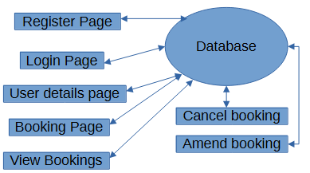

Testing strategies:
Testing will be carried out to ensure the system meets the FR, NFR and UAC’s that I have identified. I will be using 3 types of testing data Normal data, this is typical valid inputs a real user would enter. Boundary data these are values at the extreme limits of allowed input. Erroneous data these are invalid inputs that should be rejected. Testing will occur during development and after each version has been developed and will be recorded via a testing table that has evidence such as screenshots from the system, database records that show an action has completed and an expected results vs actual results comparison. The completion criteria for this will be that all normal tests pass, boundary tests work as intended, erroneous inputs are rejected and no invalid bookings can be stored. Below are some example testing tables.

Normal data tests:

Description of test | Test data to be used (if required) | Test data type | Expected outcome | Actual outcome | Comments and intended actions
Test to see if user can register | Fname  sname  dob  email  username  password | Normal | User registers successfully | User registers successfully | N/A
Test to see if user can log in | Username  password | normal | User successfully logs in | User successfully logs in | N/A
Test to see if user can create a booking with 120 guests | Booking details through form (drop-down boxes ect)  120 | normal | User successfully creates a booking | User successfully creates a booking | N/A
Test to see if user can amend booking to change guests to 125 | 125 | normal | User can amend booking | User can amend booking | N/A
Test to see if user can change their last name | sname | normal | User can change last name | User can change last name | N/A

Boundary Test Data:

Description of test | Test data to be used (if required) | Test data type | Expected outcome | Actual outcome | Comments and intended actions
Test if user can have 200 guests in a booking | Boundary | Booking details through form (drop-down boxes ect)  200 | Booking is made | Booking is made | N/A
Test if user can end a booking at 10pm with no fee | Boundary | Booking details through form (drop-down boxes ect) | Booking is made with no extra fee | Booking is made with no extra fee | N/A
Test if user can start at a booking at 9am with no fee | Boundary | Booking details through form (drop-down boxes ect) | Booking is made with no extra fee | Booking is made with no extra fee | N/A
Test if user can make a booking with 201 guests | Boundary | Booking details through form (drop-down boxes ect) | Booking is not allowed | Booking is not allowed | N/A
Test if user can make a booking with 0 guests | Boundary | Booking details through form (drop-down boxes ect) | Booking is not allowed | Booking is not allowed | N/A

Erroneous Test Data:

Description of test | Test data to be used (if required) | Test data type | Expected outcome | Actual outcome | Comments and intended actions
Test if user can make an account with and existing username | Fname  sname  dob  email  username  password | Erroneous | Registration is not allowed | Registration is not allowed | N/A
Test if a user can make a booking before 6am | Booking details through form (drop-down boxes ect) | Erroneous | Booking is not allowed | Booking is not allowed | N/A
Test if user can make a booking with 2000 guests | Booking details through form (drop-down boxes ect) | Erroneous | Booking is not allowed | Booking is not allowed | N/A
Test to see if user can access other bookings | N/A | Erroneous | User is only able to see their own bookings | User is only able to see their own bookings | N/A
Test if a user can make a booking after 12pm | Booking details through form (drop-down boxes ect) | Erroneous | Booking is not allowed | Booking is not allowed | N/A

